**Gaganpreet Singh Grewal**

**Ravneet Singh**

**Bojan Lazic**

**Work Breakdown**

We are three guys working on a project called Trippie. We divided the work between us as follows. Ravneet Singh is responsible for creating a mobile application and database. Gaganpreet Singh Grewal is responsible for integrating all the hardware components together. Bojan Lazic is responsible for creating GUI and linking it with database so that we can retrieve the readings from the database.

Here is the basic layout for our mobile android app and its functionality.

1. If the user is already registered in our app then the first page which to be opened will be sign in page and it will allow our user to sign in into the app. The first time users of our app will have to sign up. When the user sign up then the app will redirect the user to a page which is called as a bucket list in which user add different places according to his plan to visit.

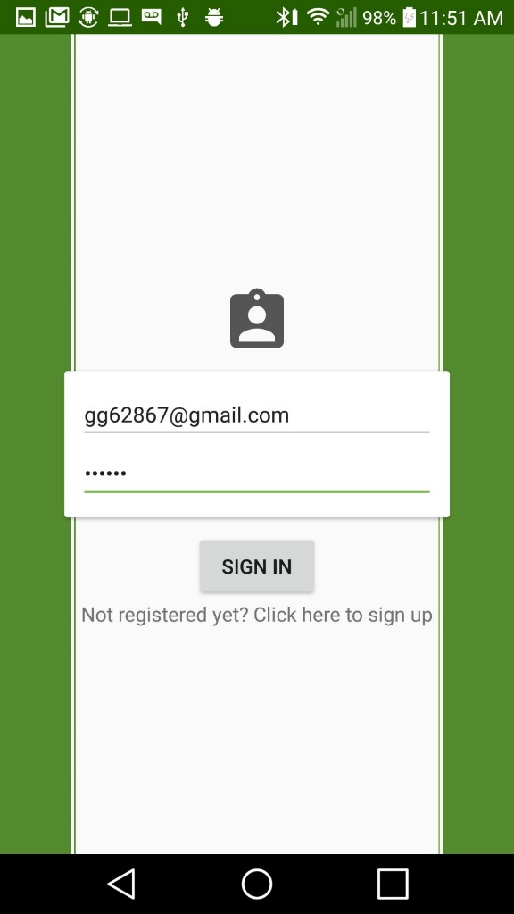

1. The signup page will allow our users to sign up for the first time and after that it will take user to a Sign in page, where users have to put email and password to further move in the app.

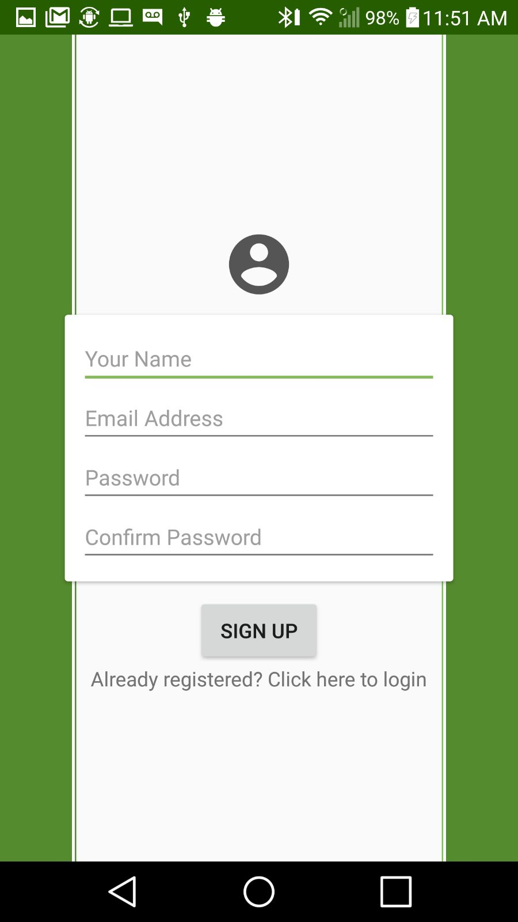

1. After signing in to the app user is able to see their bucket list in which they can add different places which they want to visit in future. This page will be linked with the firebase database and it will show the readings of the temperature at different places which user wants to visit.

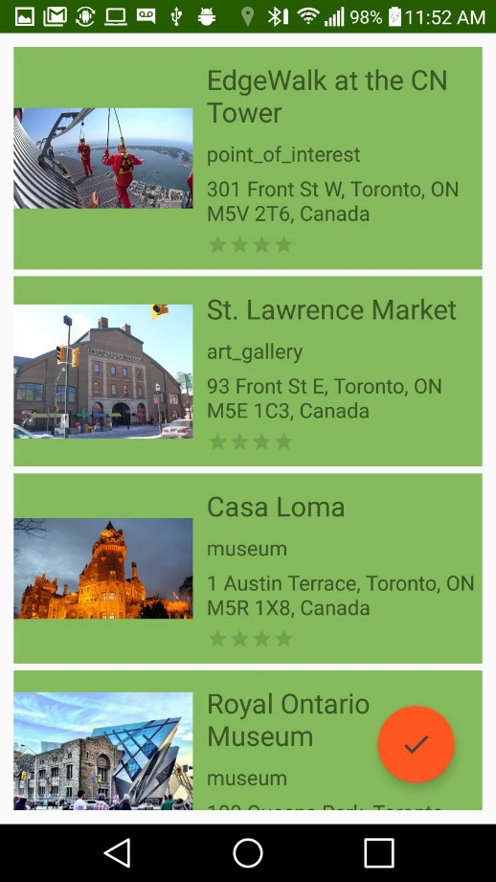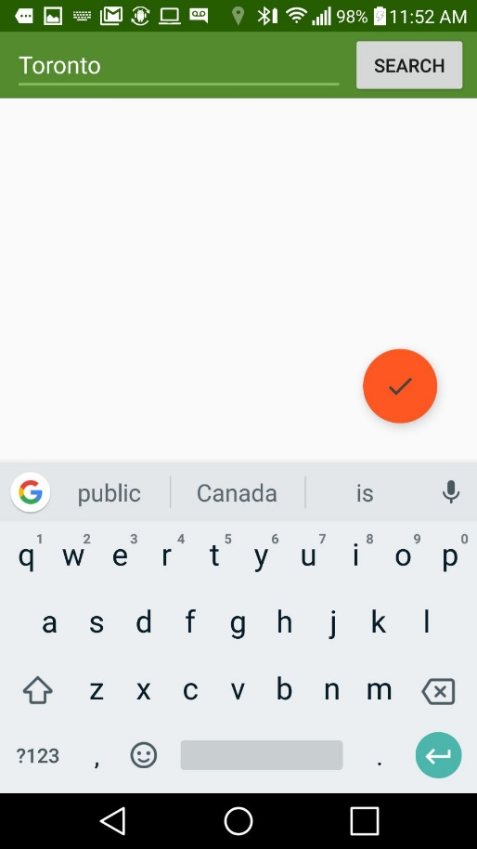

Database and work breakdown:

Our Firebase database will store the readings of the temperature and GPS. Our Android app will be connected with the database to show the readings stored on the database on mobile application.

